4. Future Strategic Initiatives

Background and Context
Based on the field experience, Reshamsutra has observed that penetration into geographies where sericulture is practised can become easier if there can be a hub created in a region. This will be the place where raw materials from neighboring villages can be procured and converted to yarn. It will be akin to a car dealership where beneficiaries from the neighboring villages can come and get advisory .

What is a Rural Experience Center?
A Rural Experience Center (REC) serves as a hub for clusters of villages practising sericulture in a region. From Resham Sutra’s point of view, REC’s will be a hub for decentralized production of yarn and a channel for selling the products. The villages lie at the end of the spokes wherein the beneficiaries reside. The villages become the center for raw material production from where the procurement happens. Rural experience centers supply machines that convert the raw material to yarn. The buyback model of Resham Sutra procures the yarn from the beneficiaries and also connects them with other probable customers. Thus, REC becomes an important center for value creation that helps in forward and backward linkage in the value chain. It is ‘akin’ to a car dealership that provides a one-stop solution to all new and potential customers. Currently, …… percent of total sales of Reshamsutra is through REC’s and it is projected to increase the sales by …. percentage.
Figure 1 depicts the Hub and Spoke Model a REC follows. The raw materials are produced in the farm-related activities in the machine. REC acting as a hub provides machines that can convert the raw material to yarn.
Figure 1: Positioning and functioning of a Rural Experience Center
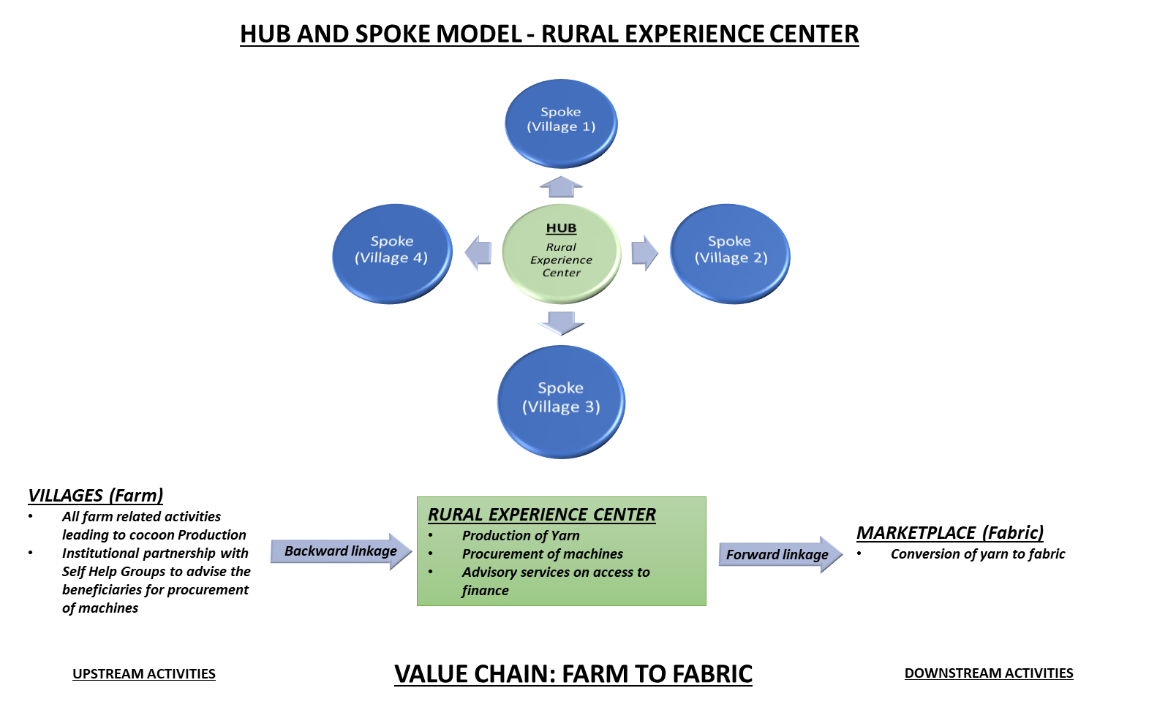

- What are the activities taken up in a Rural Experience Center?
- Live demonstration of livelihood machines to beneficiaries: Reshamsutra engages in missionary style indirect selling where the beneficiaries are educated about the product options available. With this objective, the REC demonstrates the functioning of machines to produce the yarn and provides advisory on the benefits of using the machines over the business as usual practices. (Machine sales cost)
- Advisory on easy access to finance for buying the machines: For facilitating the credit for buying the machine, RSPL will connect with the financial institutions and link them with the beneficiaries.
- Skill Development and capacity building of beneficiaries: For the penetration in the villages, Reshamsutra has partnered with the Self Help Groups in the villages. The members of these Self Help Groups will be the first set of beneficiaries whose skills will be developed in operating the machines. Besides, they will also be trained in the operations and maintenance of the machines and any other post-sales support.
- Information and Knowledge Management Centre for Visitors: REC will also become the demonstrated centre for excellence where visitors can get information about certified silk production.
- Business development support to beneficiaries: The center will provide advisory services to the beneficiaries in business planning skills that will help them in building forward linkages in the value chain.

The total budget for these activities of REC is spread across the different activities in the following pie chart below in Figure 1

Figure 1: Allocation of budget to different activities
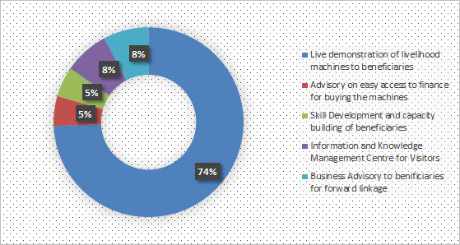

What are the key advantages of REC?
- One-stop solution for the beneficiaries to get familiarized with the innovative machines being offered as well as to get trained in operating the machines and to purchase them.
- A sales channel for deeper market penetration in difficult areas.
- A model promoting decentralized production for buying finished products like silk yarn and fabrics for rural customers.
- A profit generating center that aggregates the skill sets, raw material procurement, yarn, and fabric production, by bringing economies of scale

Who are the Partners and what is the Geography?
In total, there are six RECs planned over a period of two years. The first one which started operations in August 2020 is in Bastar district Chhattisgarh as shown in Figure 2. The white encircled region represents the hub in Bastar which will cater to the neighboring districts encircled in black. The neighboring districts which REC can cater to are Koraput, Nabarangpur, and Kalahandi, Naraynpur. REC’s are planned in the tribal regions as most of the cocoon production clusters are located in the Tribal regions. For instance, Bastar has already been identified as a principal production cluster for silk production by State Rural Livelihood Mission and has a cocoon bank. The Government is already supporting the basic seed multiplication in the villages in the district. RSPL partners with the self-help groups in the villages to reach the beneficiaries in the village. The members of the Self-Help Group are the first set of beneficiaries who receive the advisory through the Rural Experience Center on the product portfolio of RSPL. In the regions where SHGs are non-functional, RSPL facilitates the creation of SHGs.
Table 1: Geography and Partners
S. N0 | State | District | Partners
1. | Chhattisgarh | Bastar | Astitva Mahila Samiti-SHG
2. | Jharkhand | Ranchi | To be decided
3 | Assam | Guwahati | To be decided

Figure 2: Area of operation of first REC
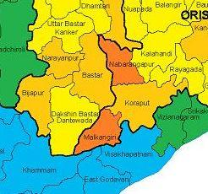

Market size and key beneficiaries
The total addressable market for one REC is 5,000 beneficiaries amounting to 5-6 crore INR. There is a plan to open six rural experience centers for which the total addressable market will amount to 30-36 crore INR. By the end of October 2021, three RECs will be operational having a total market size of 2.5- 3 crores.
In total, RECs are expected to cater to 30,000 beneficiaries. Out of this 98% of the beneficiaries are women. The current market penetration rate is 4% from 3 RECs planned in one year. Figure 2 represents the number of direct, indirect beneficiaries and total beneficiaries from REC.
Figure 3: Increase in the number of beneficiaries of Rural Experience Centers
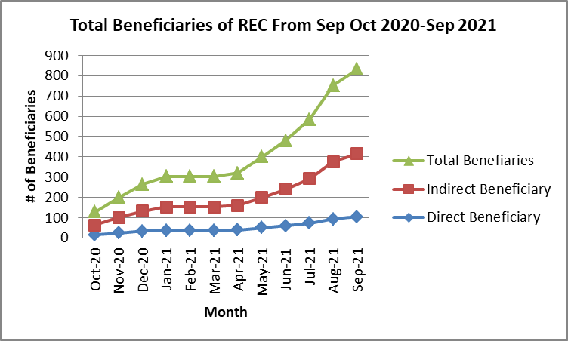

Financials
- Cost of REC: The total cost to set up one REC per year is INR 14.28 lakhs. Out of which 25% of cost is fixed cost and 75% is a variable cost. The total cost for six REC’s will be INR 85.68 lakhs.
- Return on Invested Capital: Figure 4 represents the time-line for return on invested capital for the three RECs. The break-even point for three RECs planned in Year 1 is expected to be in October 2021.
Figure 4: Return on Invested Capital for 1 Year

From Aug 2019 to March 2020, there will be one REC in Bastar, Chhattisgarh. While initially, the Return on Invested Capital will be less. However, it is expected to increase as the number of REC will increase. In April 2021, there will be one additional REC and by July 2021, there will be 3 functional RECs. In the beginning, REC sales will only be machines but gradually there will be sales of yarn also through REC which will increase the sales from REC. Thus, the break-even point for the 3 REC’s is expected to be around September 2021.

- Net Profit/ Loss by REC: Figure 5 represents the time-line for net profit/loss for three RECs to be operational. Due to initial expenses in fixed cost the RECs are expected to make losses, however it is expected that by the end of September 21, RECs will make a net profit of 7%.
- The key drivers of profit of REC are the sales from machines and yarn. In the beginning the sales in both segments are expected to be low but the sales through RECs in the two segments will increase and together the two segments will drive the profit upto 7% in one year.
- In the beginning only 2% of the expected sales from the machine segment was from REC but the number is expected to increase by 8% by the end of the year.
- For the yarn segment, in the initial stages 10% of the total sales is expected to be from the REC and it will increase to 15% by the year end.

Figure 5: Net Profit/Loss by REC in 1 Year

- Theory of change and Impact of Rural Experience Centers
Rural Experience Centers are important sales channels expected to provide easy access to renewable energy based machines to the women beneficiaries. Adoption of these machines will increase productivity as well as occupational health safety of women. The Rural Experience center helps Resham Sutra to contribute to the fulfillment of United Nations Sustainable Development Goals
      - Aaiming to end poverty for all (SDG 1),
      - Promote gender equality (SDG 5) and
      - Access to clean energy (SDG7).

Fig 6: Theory of Change for Rural Experience Center

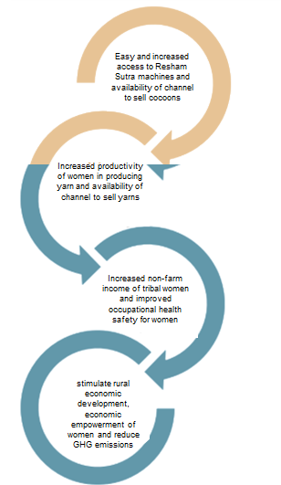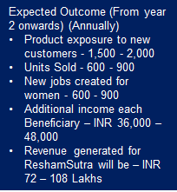

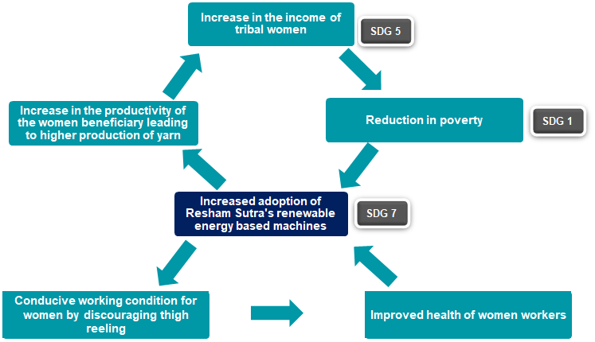

http://www.mksptasar.in/adminpradanmkc/reports/262_Tasar_VCA_Chhattisgarh_Chhattisgarh.pdf

